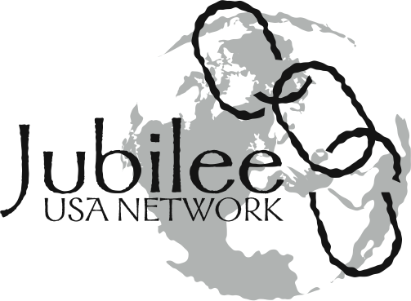MAKE A PAPER CHAIN TODAY
Make a chain today and add your voice to the chorus calling for just policies for the world’s most impoverished.

Join Jubilee USA this fall in sending messages to our leaders declaring the importance of debt cancellation and economic justice by making paper chains. Jubilee supporters across the country and from the Global South will be making chains to deliver at a demonstration at the World Bank and International Monetary Fund annual meeting on October 8, 2010.

Why Paper Chains? A Glance Into the Jubilee Movement
In the late 1990s, citizens of forty countries joined together to form the first truly international movement to call for the cancellation of debt that impoverished many countries in the Global South.

On May 16, 1998, 70,000 protesters gathered in Birmingham, London, outside of the G7 meetings and formed a human chain. The chain represented the burden of debt that enslaved many of the world’s poorest countries and called on leaders to break the chains of debt. Their linked arms also represented the hope and unity of those all over the world calling for the Jubilee vision of right relationships and economic justice.

Out of the Jubilee 2000 campaign came the first 100% debt cancellation agreement. In 1999, the G7 (G-8 financial ministers, excluding Russia) meeting in Cologne, Germany, agreed to the debt cancellation, and Jubilee continued to push for the US to make good on its promises. Congress responded to the growing pressure to address debt relief issues in 2000 by committing $769 million to bilateral and multilateral debt relief. The strength of the call for debt cancellation without harmful conditions continued to grow, and in 2005, the richest countries and financial institutions agreed to expand debt cancellation. Today over $100 billion of debt has been cancelled in 29 countries.

Now in 2010, Jubilee USA Network is a strong voice for debt cancellation and real structural change. This fall, we will once again form a chain to call on our world leaders to answer the call of Jubilee. With the financial crisis looming over our own countries and causing even greater economic devastation in the Global South, our work is even more urgent.

On October 10, Jubilee USA will be joining over 297 organizations from 60 countries in the Week of Action against Illegitimate Debt. We will lift our voices in solidarity with our brothers and sisters across the globe, and we ask that you join us.

Instructions:
- Copy the enclosed two-sided sheet onto colored paper.
- Cut the links apart. Sample chain links are provided.
- Distribute the chain links at your Jubilee Sunday and your Stand Up, Take Action event.
- Set up a table in your church and include them in the worship bulletin. Have individuals write messages on the back to the IMF and World Bank. You could also host a chain making party where you gather a group to assemble paper chains in large quantities.
- As soon as possible send your chains or flat chain links (and pictures of your chain making party) to Jubilee USA (212 E. Capitol St., NE, Washington, DC 20003).

We look forward to carrying your chains with us on the day of our demonstration to send a strong message to our leaders that we need to drop the debt!

Break the Chains! Fix the System!
Ending the Harmful Practices of the International Monetary Fund and World Bank to Help the World’s Poorest

The World Bank and IMF are two of the most important international lending organizations (also called international financial institutions). In addition to controlling many of the loans that are most burdensome for the world’s poorest countries, these institutions have imposed strict conditions on these countries in order for them to receive debt cancellation and to be eligible for other assistance.

We can celebrate the achievements of the Jubilee movement so far. Thanks to the work of activists around the world, most harmful conditions placed on loans have been stopped. Still, we have more work to do. We must hold these institutions accountable and push for significant reforms.

For example, in order to get debt cancellation under the Heavily Indebted Poor Countries Initiative:

- Zambia was forced to limit spending by freezing wages and hiring, leaving the country short 9,000 desperately needed teachers. IMF’s requirement to lower trade barriers also resulted in the loss of 30,000 jobs in their textile industry.
- Nicaragua had to privatize electricity. Electricity prices rose by 200%, pricing the poor out of the market.

The IMF in the Economic Crisis
The US and other global economic leaders have the power to increase spending during a recession in order to stimulate the economy. However, the IMF has never let poor countries do this, favoring $0 deficits over anything else, including investments in education and healthcare. The IMF has loosened up on these restrictions in some countries, especially middle-income countries. Yet, research shows that the IMF’s conditions for new loans during the crisis have led to countries cutting important services:

- In its January 2009 loan to El Salvador, the IMF required tax increases and cuts in gas and transport subsidies.
- As a requirement of its loan to Ethiopia, the IMF cut the country’s fuel subsidies. A few pennies more on gas can mean the difference between getting to school or to the hospital.

How Can We Help?
Already the US Congress has used its influence on the IMF and World Bank to end the requirement that the world’s poorest countries implement user fees for basic primary education and last year voted to make sure that the IMF did not impose restrictions on health care spending in the poorest countries. As the biggest voter in the IMF and World Bank, the United States has an important leadership role and can use its influence to promote fair and just policies. We must hold them accountable.

This year, the Jubilee USA Network is pushing the Obama Administration to expand debt cancellation without harmful economic conditions, reform the international financial institutions, and establish a new and fair system for lending and borrowing. This October we will put our power behind these policy proposals by making chains.

For more information, visit www.jubileeusa.org or email brooke@jubileeusa.org.

